ADVERTISEMENT for BIDS
TOWN OF CHESTERFIELD, South Carolina
Gravity Sewer I & I Study and Pump Station Standby Generators SRF Project No. 485-01
The Town of Chesterfield (Owner) is requesting Bids for the construction of the following Projects:
Contract 1: | Gravity Sewer Study  SRF No. 485-01
Contract 2: | Emergency Standby Propane Generators w/ ATS  SRF No. 485-01
Bids for the Projects will be received at the Town of Chesterfield Town Hall located at Olde Towne Centre, • 112 Main Street, • Chesterfield, SC 29709, until August 25, 2022, at 2:00 pm local time. At that time the Bids received will be "publicM' opened and read.
The Projects includes the following Work:
Contract 1: Conduct a Study of the Gravity Sewer System using:
I-Tracker Flow Tracking Technology
MACP Level 2 Manhole Inspection
GPS Manhole Coordinates & Information
Smoke Testing
Cleaning & CCTV Inspection
Assessment Report & GPS Mapping
Contract 2: Provide and Install Standby propane fueled generators w/ Automatic Transfer
Switches at:
- County Jail Sewer Pump Station
- Chesterfield/Ruby Middle School Sewer Pump Station
Separate Bids will be received for the following Contracts:
Contract No. | Description of Contract
1. | Gravity Sewer Study and Report
2. | Emergency Standby Generators w/ ATS
The Project has an expected duration of:
Contract 1: 365 days
Contract 2: 180 days

EJCDC^{Ø} C-111, Advertisement for Bids for Construction Contracts.
Cowrøt 0 2013 National Sodety of Professional Engineers, American Council of Engineering Companies, and American Society of Civil Engineers. All rights reserved. Page I
Bidders shall note that the following apply to both Contract 1 and Contract 2:
This project is being funded by a loan from the State Revolving Fund and all bidders must comply with all applicable state and federal requirements identified in the bid documents — including "Davis-Bacon" and "American Iron and Steel" provisions.
Bidders must implement procedures that ensure that EEO/DBE firms are given opportunities for meaningful participation if sub-contracts are awarded.
Bidders must provide a 5% Bid Bond with their bid.
Obtaining the Bidding Documents
Neither Owner nor Engineer will be responsible for Bidding Documents, including addenda, if any, obtained from sources other than the designated Bidding Office.
The Issuing Office for the Bidding Documents is:
Kellahan Brothers Engineering
5711 Thurgood Marshall Hwy

Kingstree, SC 29556
Email: myron@kellahanbros.com
Prospective Bidders may obtain or examine the Bidding Documents at the Issuing Office on Monday through Friday between the hours of 9:00 am- 3:30 pm and may obtain copies of the Bidding
Documents from the Issuing Office as described below. Partial sets of Bidding Documents will not be available from the Issuing Office. Neither Owner nor Engineer will be responsible for full or partial sets of Bidding Documents, including addenda, if any, obtained from sources other than the Issuing Office.
Bidding Documents may be purchased from the Issuing Office during the hours indicated above. Cost does not include shipping charges. Upon Issuing Office's receipt of payment, printed Bidding Documents or electronic documents on USB disk will be sent via the prospective Bidder's delivery service. The shipping charge amount will depend on the shipping method chosen. Bidding Documents are available for purchase in the following formats:
Format | Cost
Bidding Documents (including Full-Size Drawings) | $300.00
Bidding Documents (including Half-Size Drawings) | 200.00
Electronic download of Biddin Documents from shared file | $50.00
Pre-bid Conference- None
Instructions to Bidders.
For all further requirements regarding bid submittal, qualifications, procedures, and contract award, refer to the Instructions to Bidders that are included in the Bidding Documents.
This Advertisement is issued by:
Owner: The Town of Chesterfield

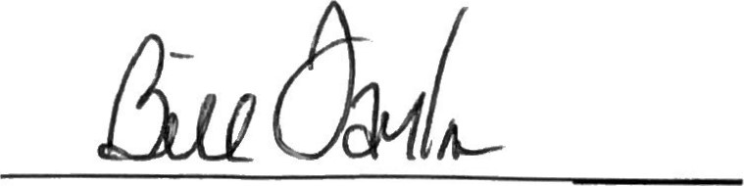
By: Bill Taylor
Title: Administrator
(843) 623-2131
Mr. Bill Taylor, Administrator
Town of Chesterfield

+ + END OF ADVERTISEMENT FOR BIDS + +

EJCDC^{Ø} C-111, Advertisement for Bids for Construction Contracts.
Copyrøt@ 2013 National Sodety of Professional Engineers, American Council of Engineering Compa nies, and American Society of Civil Engineers. All rights reserved. Page 2

