APPLICATION for use of THE CRAIG PARK COMMUNITY HUT
TOWN OF CHESTERFIELD RENTAL FACILITIES
**Masks & Social Distancing recommended**

This application must be completed in its entirety. Please type or print legibly.
Name of Responsible Person (Name of Organization/Group Representing: (If non-profit, please provide documentation)) Applying: _____________________________________________________________________________

Address __________________________________________ Phone Number: ______________

Date/Time of Use: _________________________________Number of People Expected: _____

Type of Program/Nature of Use: ___________________________________________
Admission Will/Will Not be charged. Proceeds to be used for:____________________
Will beer or wine be served? (No liquor is allowed.) Yes _________ No____________, if yes insurance is required. Gatherguard.com for policy. Proof required to rental. If alcohol is served without insurance, your rental is voided. Insurance Yes _________ No____________

THE TOWN RESERVES THE RIGHT TO CANCEL ANY RESERVATION AT ANYTIME. If the town cancels your reservation, you may reschedule to another date or receive a full refund.

All Town Facilities are under the JURSIDICATION of the CHESTERFIELD POLICE DEPARTMENT and are SUBJECT to MONITORING of all ACTIVITIES/EVENTS.

All Rental Fees and Deposit for a total of $400.00 must be paid in advance and in full to reserve your date. No partial payments accepted. The deposit DOES NOT secure your date. (The key must be picked on Friday or the last workday prior to weekend day rental. Failure to do so will result in forfeiture of the deposit. Only one set of keys per rental day are given). IF I CANNOT BE LOCATED within a reasonable period of time to receive the refund of my deposit, I hereby request that my deposit be retained by The Town of Chesterfield and used locally rather than being forwarded to the State of South Carolina Unclaimed Property Division. NO BOUNCE HOUSES.

I promise to personally assume responsibility for payment of all charges and the observance of all regulations governing the use of this facility.

______________________________________________________________________
Applicant Signature Date Signed
Office Use Only
Rental Fee and Deposit must be paid in advance and in full to reserve your date.
Rental Fee (Amount): $275.00 Date: ______________
Deposit (Amount): $125.00 Date: ______________

I certify that I have received the $ deposit for the rental of the Craig Park Community Hut on

Date ________. _________________________________________________
Signature of Person Making Reservation

Hut Deposit Rules/Guidelines/Reservation Agreement

All deposits must be picked up within 10 calendar days after the rental date. After this time, the Town of Chesterfield will not be held responsible for any money, including cash or checks. The following rules and guidelines apply to the users of the facility.

- NO FRYING FOODS ON THE STOVE(S) OR IN THE BUILDING. Warming kitchen only.
- No smoking or tobacco use in the building or grounds as posted. Alcoholic beverages are not allowed in the building or on the grounds without prior written approval from the Town of Chesterfield.
- A responsible adult of at least 21 years of age shall remain on the premises for the entire duration of any event.
- All trash, paper products, food, decorations, etc. must be removed from the building and placed in the trash receptacles. The user (renter) is responsible for removal of the above items, even if they have contracted with a party/wedding coordinator or caterer.
- NO GLITTER OR CONFETTI CAN BE LEFT ON THE FLOOR, YOU WILL BE RESPONSIBLE FOR SWEEPING IT UP AND/OR SUBJECT TO YOUR DEPOSIT BEING FORFEITED FOR ADDITIONAL CLEAN-UP COSTS.
- The renter is responsible for securing the facility including turning off the lights, HVAC, stove, water in restrooms and closing/locking the facility at the end of the event.
- Bathrooms must be left in presentable condition.
- The Town is not responsible for setting up or taking down any tables or chairs.
- Any equipment used shall be returned to its original location. No equipment, material, or furniture may be removed from the facility.
- Litter scattered over the outside area as a result of the particular event shall be picked up by the renting party.
- The renter is solely responsible for any damages occurring to the facility or equipment. The required deposit fees may be used to satisfy such damages and/or extra cleaning that may be required. Additional charges (exceeding the deposit) may be assessed as needed, to cover additional repair costs.
- Changes to wires, wiring, electrical, or audio/video connections are strictly forbidden.
- Seating for up to 204 (not guaranteed) Tables: up 4-6ft rectangle 9-8ft, rectangle and 13-6ft round. (not guaranteed.)
- Fire exits must not be blocked by tables, chairs, or equipment of any kind.
- Town personnel staff will inspect the facility and equipment after each rental.
- For an emergency regarding the facility contact the Chesterfield Police Department 843-632-2419.

Failure to comply with these rules may result in a forfeiture of all or a portion of the required deposit and may result in additional charges. The deposit will be refunded after the facility and equipment has been checked and the keys are returned. We require two separate checks to be written – one for the deposit and one for the rental fee.

I have read and reviewed the rules and guidelines and understand that failure to comply may result in the forfeiture of all or a portion of the deposit.

Signature of Responsible Party: ______________________________Date: _______

Hut Deposit Rules/Guidelines/Reservation Agreement

The Public Properties Department welcomes you and your group to use the facility. In using the facility you will agree to the following conditions and terms. The Town reserves the right to cancel a reservation at any time. In such instances, the deposit and rental fee will be refunded.

- A deposit and rental/cleaning fee is required at the time of reservation. This is a requisite for making a reservation. You DO NOT have a confirmed reservation until you have paid both the deposit and the rental fee. Fees are subject to change at any time. Reservations are to be made two weeks in advance.
- Failure to notify the department of the cancellation of your function at least seven (7) days prior to the event will result in the forfeiture of your deposit.
- The Town of Chesterfield is not responsible for any injuries received on facility premises.
- The building and equipment will be left in a condition equal to or better than found.
- No alcoholic beverages are allowed during public events or on the grounds, including the park unless prior written permission from the town is granted. No smoking or tobacco use is allowed in any facility or premises as posted.
- The renter has usage of the facility only for the time specified on the application form and shall not use any area of the facility at any other time. (Unauthorized usage will result in additional charges and forwarded to the Police for any additional action needed.)
- To avoid competition with existing private sector businesses, the Town will only rent its facilities to chartered tax exempt organizations when the purpose of the rental is for the raising of funds, i.e. the facilities will not be rented to individuals or businesses, peddlers, etc., when it’s their intent to sell tickets, charge admission or sell goods for the purpose of financial gains.
- The key must be picked on Friday or last workday prior to weekend day rental. Failure to do so will result in forfeiture of the deposit. Only one set of keys per rental day will be provided.
- The Town Council reserves the right to waiver the aforementioned policy at its discretion.

Normal Rental Times are as follows:
9:00 AM – 10:00 PM Sunday through Saturday

You are not allowed to use the building any other time
(ONLY THE DAY YOU ACTUALLY RENTED)!!!
This includes for your caterer, decorator, wedding planner, florist, etc. (If you need additional time,
additional days may be rented for a reduced fee.)

Failure to comply with these rules may result in a forfeiture of all or a portion of the required deposit and may result in additional charges. I have read and reviewed the rules and guidelines and understand that failure to comply may result in the forfeiture of all or a portion of the deposit.

Signature of Responsible Party: ____________________________Date__________

HOW CHAIRS AND TABLES ARE TO BE RESTACKED.
PART OR ALL OF DEPOSIT MAY BE RETAINED IF CHAIRS AND TABLES ARE NOT PUT BACK IN THIS MANNER.
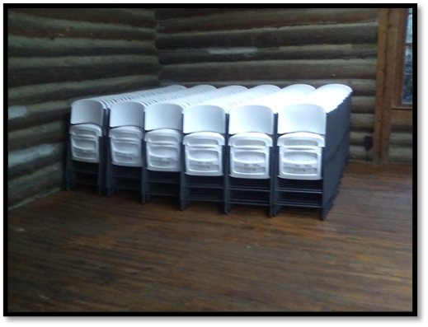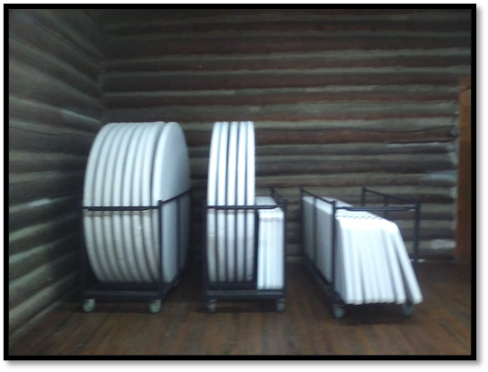

Signature of Responsible Party: ____________________________Date__________

